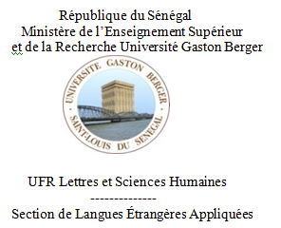
Prof: Dr DIOP

CMC Britannique/Licence 1
Answer the following questions (about 50 words for each one)
- List the positive ad negative aspects of the British empire on the African colonies.
……………………………………………………………………………………………………………………………………………………………………………………………………………………………………………………………………………………………………………………………………………………………………………………………………………………………………………………………………

- Should the British apologise for its colonial past ? Why/Why not ?
…………………………………………………………………………………………………………………………………………………………………………………………………………………………………………………………………………………………………………………………………………………………………………

Brexit: what’s the British Empire got to do with it?

…………………………………………………………………………………………………………………………………………………………………………………………………………………………………………………………………………………………………………………………………………………………………………

What are the social issues of the Brexit?

…………………………………………………………………………………………………………………………………………………………………………………………………………………………………………………………………………………………………………………………………………………………………………

