The British Empire through time
An 'empire' is a group of countries ruled over by a single monarch or ruling power. An empire doesn't need an 'emperor'. The British Empire comprised of Britain, the 'mother country', and the colonies, countries ruled to some degree by and from Britain.
The British began to establish overseas colonies in the 16th century. By 1783, Britain had a large empire with colonies in America and the West Indies. This 'first British Empire' came to an end after the American Revolution.
However, in the 19th century, the British built a second worldwide empire, based on British sea-power, made up of India and huge conquests in Africa.

A snapshot of the British Empire in 1922
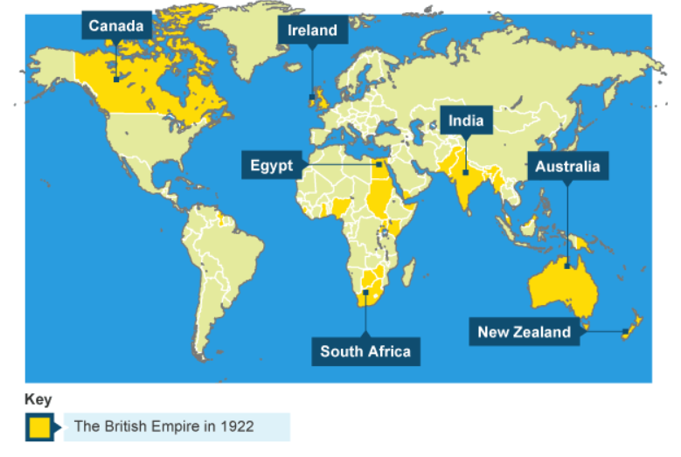
The British generally felt that the way they lived their lives was the right way. They believed that colonising various countries was a means of helping others to become like Britain and therefore improve.
- In 1947, India and Pakistan were given independence.
- In 1960, British Prime Minister, Harold Macmillan admitted there was a "wind of change" in Africa. Most of Britain's African and Caribbean colonies achieved independence in the 1960s.
- In 1973, Britain joined the European Economic Community and became part of a trading community based on free trade between the countries of Europe.
- In 1997, Britain formally handed Hong Kong back to China.

The Commonwealth
The Commonwealth is a voluntary association of 54 independent and equal countries. It is home to 2.4 billion people, and includes both advanced economies and developing countries.
The members work together to promote prosperity, democracy and peace, amplify the voice of small states, and protect the environment.

United Kingdom in the Commonwealth

The Commonwealth, once known as the British Commonwealth of Nations, has its roots in colonialism and the British Empire.
The Commonwealth has its roots in the British Empire. After some countries around the world began gaining some level of freedom from Britain, they became known as "dominions," and the leaders of dominions attended conferences beginning in 1887.
In 1926, at the Imperial Conference, leaders of several countries—Australia, Canada, India, the Irish Free State, Newfoundland, New Zealand, and South Africa—agreed with Britain that they were "equal in status, in no way subordinate one to another in any aspect of their domestic or external affairs, though united by common allegiance to the Crown, and freely associated as members of the British Commonwealth of Nations." This agreement was formalized in the Statute of Westminster in 1931, and agreed to by Canada, the Irish Free State, Newfoundland, and the Union of South Africa, but declined by Australia and New Zealand; India is left out, after its relationship with Britain worsened.
But it wasn't until 1949, with the London Declaration, that Commonwealth member countries were no longer required to have the British monarch as their Head of State. This decision was made after India—which joined the Commonwealth in 1947—declared that it would become a republic, but wanted to remain in the Commonwealth. The association dropped "British" from its title, becoming the Commonwealth of Nations, and its member countries were required to recognize reigning monarch King George VI as Head of the Commonwealth, rather than their Head of State.
The first members of the Commonwealth of Nations were the UK, Canada, Australia, New Zealand, South Africa, India, Pakistan, and Ceylon (later Sri Lanka). (In the years between 1926 and 1949, several countries joined and left the association.)

Today the Commonwealth is a voluntary association of 54 independent countries, made up of 2.4 billion people, who work together to promote shared interests.
The Queen is head of state of 16 countries that are a part of the Commonwealth realm, including the UK.
These include Australia, Canada and New Zealand, as well as several island nations in the Caribbean and Indian Ocean.
These are Antigua and Barbuda, Barbados, The Bahamas, Belize, Grenada, Jamaica, Papua New Guinea, Saint Lucia, Solomon Islands, St Kitts and Nevis, and St Vincent and the Grenadines.
In London, the UK hosts the HQ of the Commonwealth Secretariat, Commonwealth Foundation, Association of Commonwealth Universities, Commonwealth Enterprise and Investment Council, Commonwealth Games Federation, Commonwealth Local Government Forum and Commonwealth Parliamentary Association.
Scholarships and fellowships are awarded by the UK to citizens of other Commonwealth countries under the Commonwealth Scholarship and Fellowship Plan.

