CMC Britannique

UK and its components. UK Political system. Education in the UK. Understanding the British Culture and Society. The British Empire through time. Brexit. Post Brexit. British Former Colonies.The Commonwealth. UK nad the rest of the World.
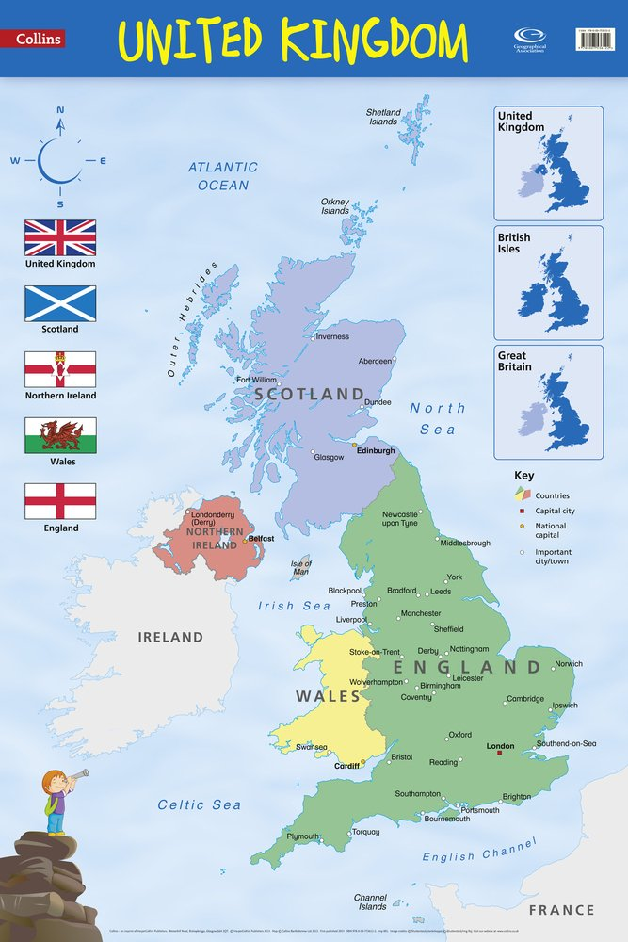
- Four nations in one
- Flags

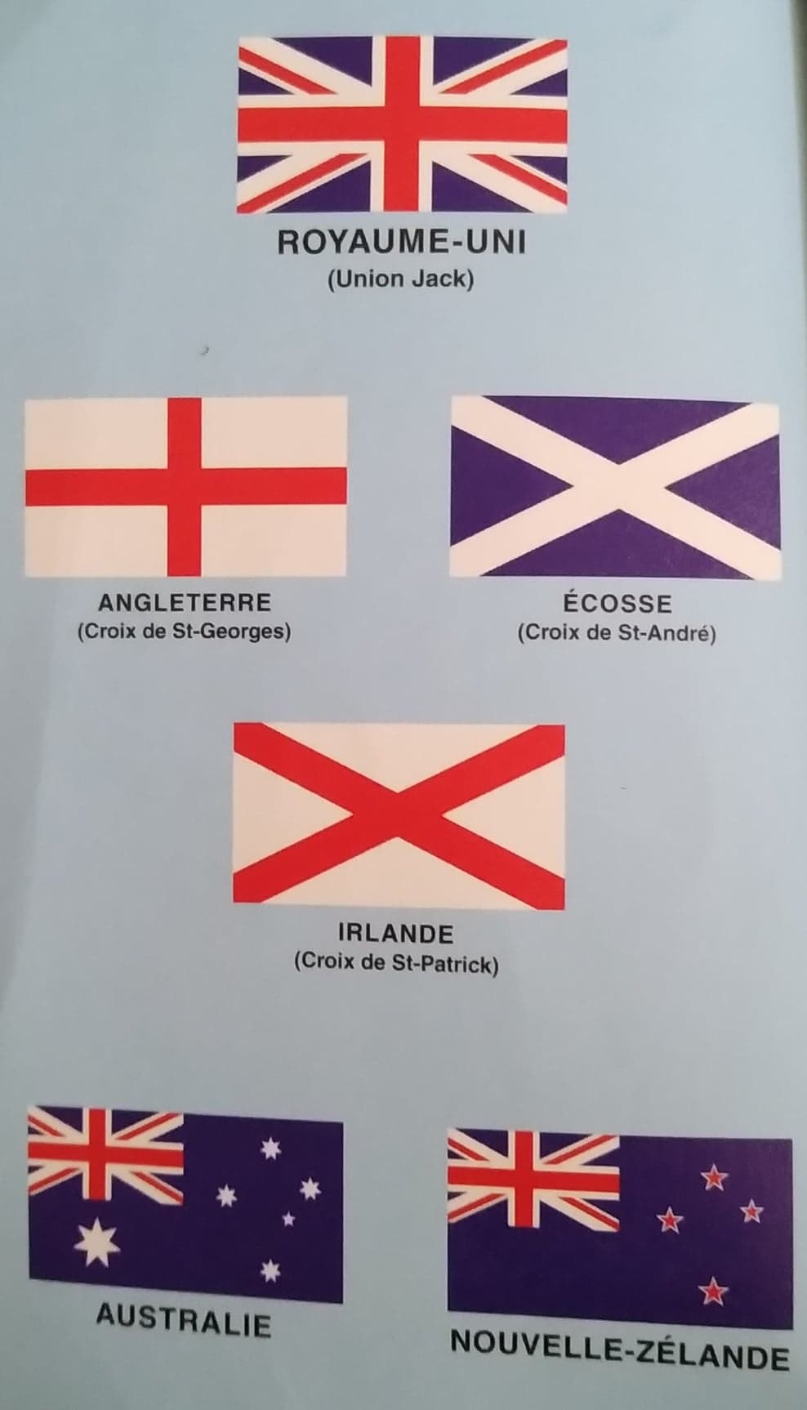

- National days and celebrations
.
Natural resources, ports and climate

Population

The Constitution

UK POLITICAL SYSTEM

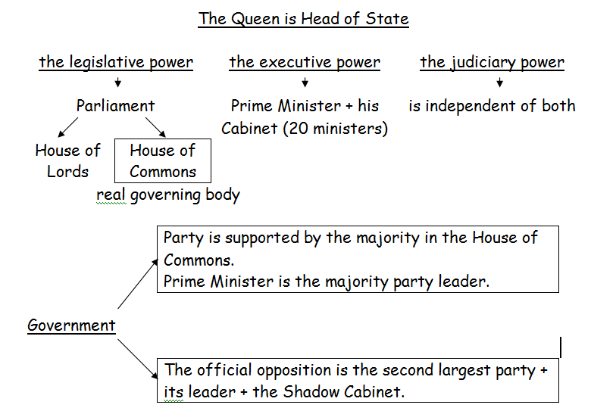

The press

Newspapers

TV

Radio

EDUCATION IN THE UK

BRITISH CULTURE AND SOCIETY

Religion and Beliefs

Major Celebrations/Secular Celebrations

The Family

Economy

Food

Arts, Humanities and Popular Culture

Visiting a home

Taboos
A poem to better understand the British Melting Pot

The British Empire through time
The Commonwealth

United Kingdom in the Commonwealth
Britain’s Contribution to the world.
Brexit

What does Brexit mean?
Brexit and social issues:
Brexit and economic issues

What future awaits the UK and the European
Union countriesafter Brexit?

