- Presentation of the British Isles

- The British Isles constitute an archipelago and lie off the North-western coast of European mainland (opposed to an isle: continent)
- They are surrounded by the Atlantic Ocean and the North Sea which is to its eastern part, and separated from the European continent by the English channel to the far South
- Their two biggest isles, namely Great Britain and Ireland, are separated by the Irish Sea.
- They are composed of a great number of isles (over 6,000)
- The largest part of the British Isles is Great Britain, and the second largest is Ireland
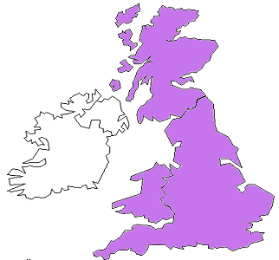
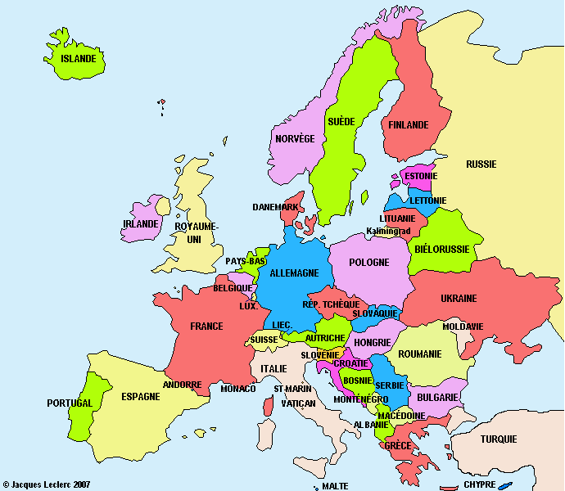
I.1. Great Britain
- Composed of three different nations: England, Scotland and Wales
- The greatest and most populous isle of Europe, representing 66% of the total area of the British Isles

I.1.1. England
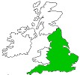
- Located to the South of the British Isles, England is, in terms of area, population and even politically speaking, the dominating country of Great Britain (130,000 sq km for over 50 million inhabitants)
- Its capital city is London to the South-east and is the largest city of the country
- Its major cities include the West midland towns such as Birmingham, Leeds, York, Bradford, and Sheffield; Liverpool and Manchester situated to the North-west; and Newcastle to the North-east
- The inhabitants of England are called the English and English is their official language
- Cornish is another language spoken by a minority group within England (in Cornwall) and that assume their cultural difference with English people
- Saint George, celebrated every year on April 23rd, is the patron saint of England; and the English flag bears the cross of Saint George (a red cross)
- National football team

I.1.2. Scotland
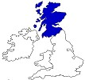
- It is to the North of England and is the second largest nation of Great Britain (77,000 square km and about 6 million inhabitants)
- Edinburgh is its capital
- Glasgow is another major city of Scotland (bigger than Edinburgh) and to a lesser extent Aberdeen and Dundee
- Scotland is remarkable for its good number of islands (790 islands of which only 130 are inhabited)
- The most famous three groups of islands located in Scotland are: the Orkney islands and the Shetland islands to the North east, and the Hebrides to the west. Each of these groups is made up of a certain number of much smaller islands
- Spoken languages: English, Scottish Gaelic, and Scots (the latter two are national languages and are being promoted. Since 2005 Gaelic, for example, has been an official language alongside English, and both languages enjoy an equal consideration)
- The inhabitants of Scotland are called the Scots, and Scottish is used as an adjective
- Saint Andrew, whose cross can be found in the Scottish flag, is the patron saint of the country and is celebrated on November 30th every year
- It has its own national football team

I.1.3. Wales
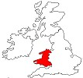
- To the West of England
- The smallest nation of Great Britain with an area of almost 21,000 sq km inhabited by around 4 million people
- Cardiff is its capital city and other main cities include Swansea and Newport
- The inhabitants of Wales are the Welsh
- It is not a sovereign State, for it is incorporated in England and can be seen as an English province
- It has two official languages, Welsh and English, both taught at school, chiefly at state or public schools
- The Welsh flag is represented by a red dragon on a green background
- Its patron saint is St David celebrated annually on March 1st
- National football team
I.2. Ireland
- The second largest island of the British Isles occupying 26% of the area
- It is located to the west of Great Britain, but is separated from it by the Irish sea
- The country was divided into two nations since 1922: Southern Ireland and Northern Ireland. St Patrick, celebrated on March 17th every year, is the patron saint of both Northern and Southern Ireland
- Northern Ireland (the northern part of Ireland) also called Ulster is only 21 km away from the coast of Scotland
- It has a small area of 13,000 square km that represents 1/5 of the whole Irish land. The figure of its population is about 2,5 million people
- It is a largely rural region and its capital city is Belfast
- Its inhabitants are referred to as the Northern Irish. Irish, Ulster Scots and English are spoken languages
- The nation is crippled for many years by an internal, religious and political conflict between Protestants and Catholics, the former being the majority.
- Northern Ireland does not have a definite national flag; its official flag is, in principle, that of the UK, but because of a problem related to national identity, the Northern Irish flag proves to be a complex and sensitive issue. For example, those who want Northern Ireland to be withdrawn from the UK and incorporated in Southern Ireland consider the southern Irish flag to be also that of Northern Ireland…
- Southern Ireland occupies 4/5 of the total area of the island of Ireland; as opposed to Northern Ireland, it is a totally independent State and its populations are Catholics in the majority
- Since 1949 Ireland became a republic and is also called the Irish Free State or Eire
- Dublin is its capital city
- Its flag bears the cross of St Patrick
I.3. A multitude of smaller islands
- The British Isles or to be more appropriate the British-Irish isles are also composed of lot of other small islands
- Besides Great Britain, Ireland and the groups of islands mentioned above and found in Scotland, there are other relatively important islands such as the Isle of Man and Anglesey in the Irish sea, the Isles of Scilly in the Atlantic Ocean and to the south-east of England, the Channel Islands and the Isle of Wight both located in the English Channel, etc.

